**Lab 03 Part 2**

**Task 1**

<https://leetcode.com/problems/intersection-of-two-linked-lists/submissions/1385555024?envType=problem-list-v2&envId=linked-list>

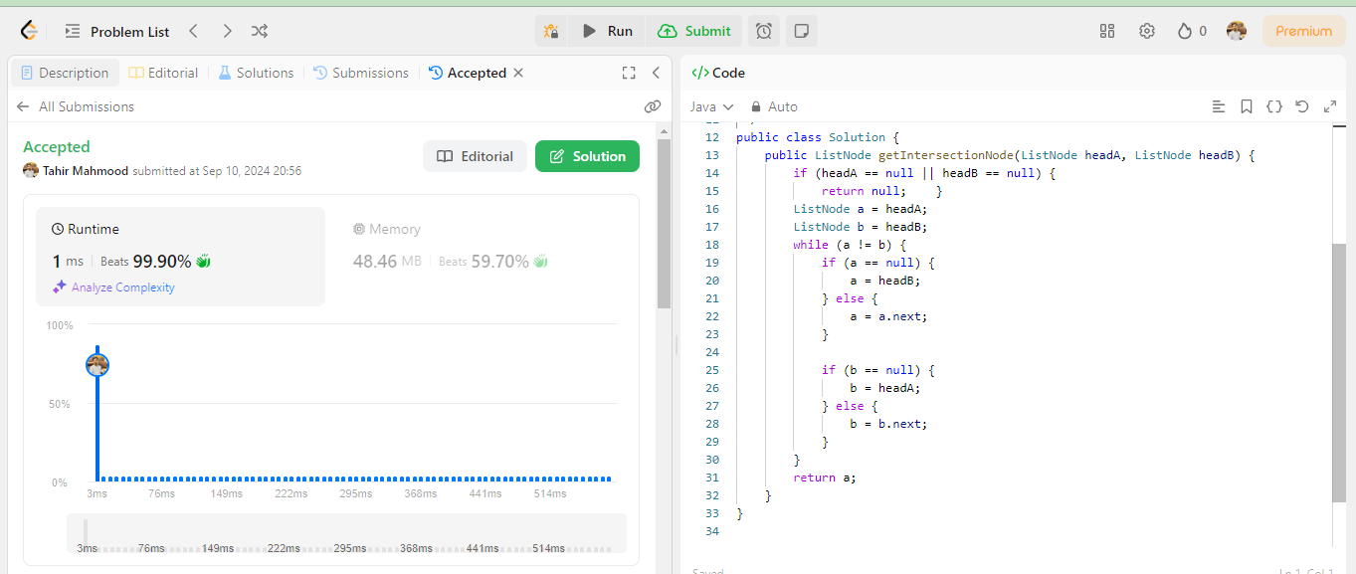

**Task 2**

<https://leetcode.com/problems/remove-duplicates-from-sorted-list/submissions/1385563193?envType=problem-list-v2&envId=linked-list>

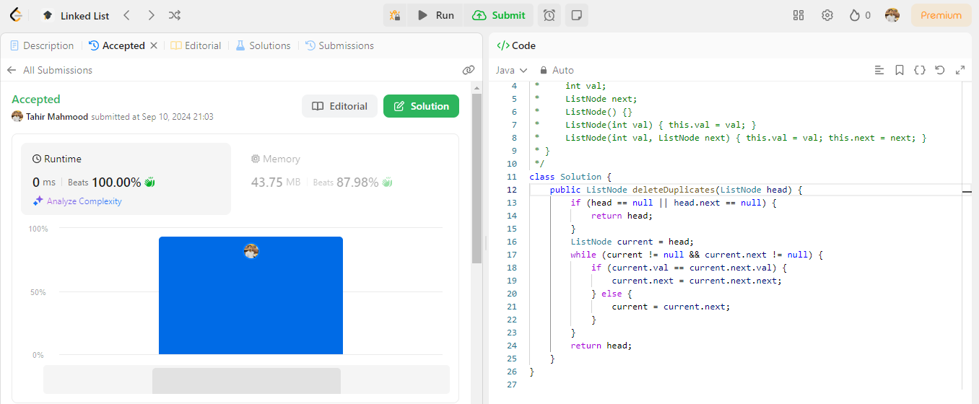

**Task 03**

<https://leetcode.com/problems/merge-two-sorted-lists/submissions/1385569891?envType=problem-list-v2&envId=linked-list>

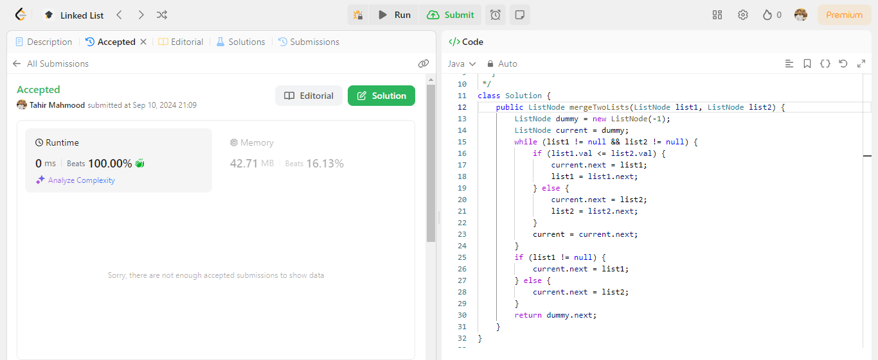

**Task 04**

<https://leetcode.com/problems/add-two-numbers/submissions/1385575188?envType=problem-list-v2&envId=linked-list>

